***CANTEEN ORDERING SYSTEM FOR UNILEVER***

***CONTENTS***

1. ***Identifying stakeholders***
2. ***Problem statement***
3. ***Objectives of the new Canteen Ordering System***
4. ***Process map***
5. ***Context Diagram of Canteen Ordering system***
6. ***Main features that need to be developed***
7. ***Write the in-scope and out-of-scope items for this software -***
8. ***ER diagram of the system***
9. ***Business requirement***
10. ***Wireframes of the model***

***1.IDENTIFYING STAKEHOLDERS***

***Primary Stakeholders***

* *Students and Staff: The main users who will order food and beverages.*
* *Canteen Staff: Responsible for preparing and delivering orders.*
* *Canteen Management: Overseeing operations, inventory, and finances.*

***Secondary Stakeholders***

* *IT Department: Responsible for system maintenance and security.*
* *Payment Gateway Providers: Facilitating online transactions.*
* *Suppliers: Providing ingredients and supplies to the canteen*

***2.PROBLEM STATEMENT***

* *long wait times, order mix-ups.*
* *limited payment options, leading to customer dissatisfaction and inefficiencies in service.*
* *lack of proper tracking of orders and inventory.*

***3.OBJECTIVES OF THE NEW CANTEEN ORDERING SYSTEM***

* *Efficiency: Reduce wait times and streamline order processing.*
* *Accuracy: Minimize errors in order taking and delivery.*
* *Convenience: Offer multiple payment options and a user-friendly interface.*
* *Transparency: Provide real-time updates on order status.*
* *Data****-****Driven: Enable data collection for better inventory management and customer insights*

***4.PROCESS MAP***

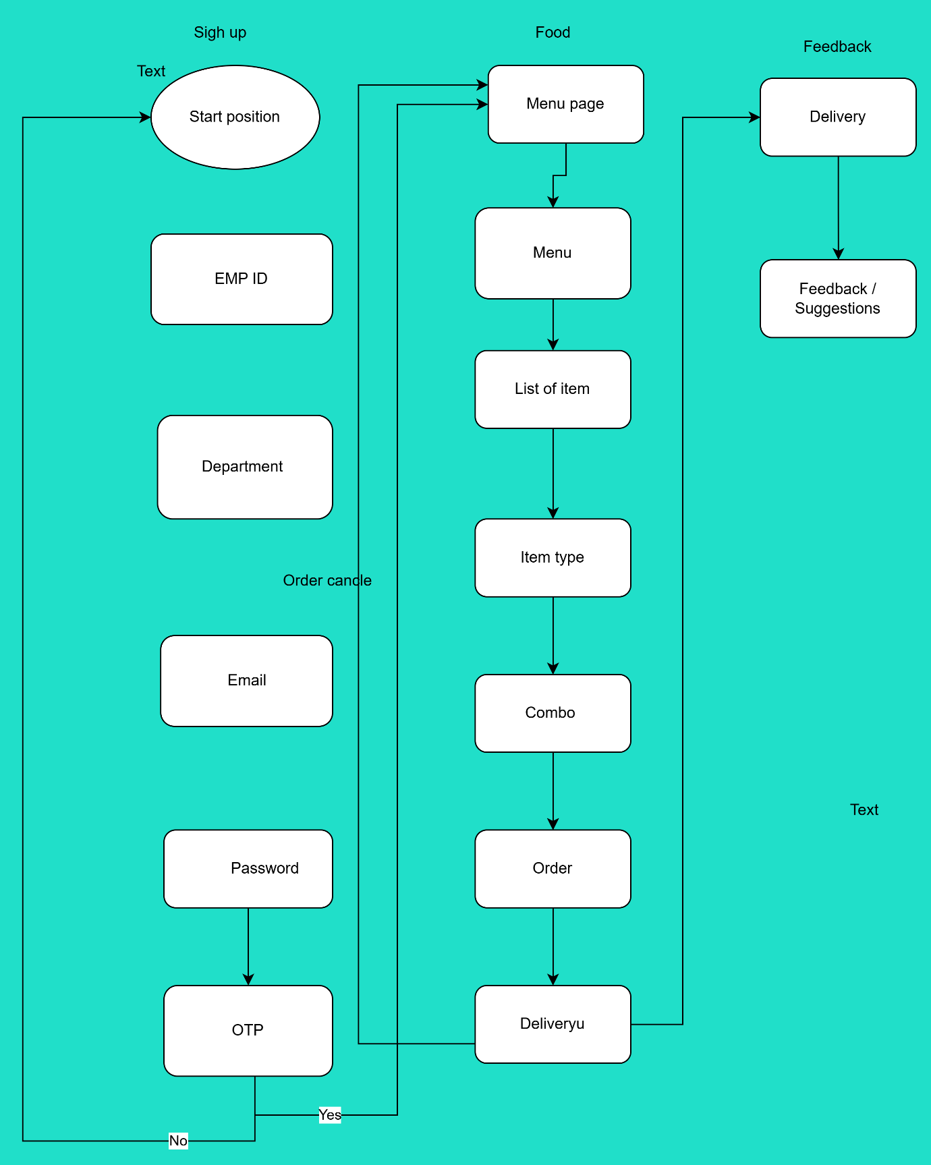

***5.CONTEXT DIAGRAM OF CANTEEN ORDERING SYSTEM***

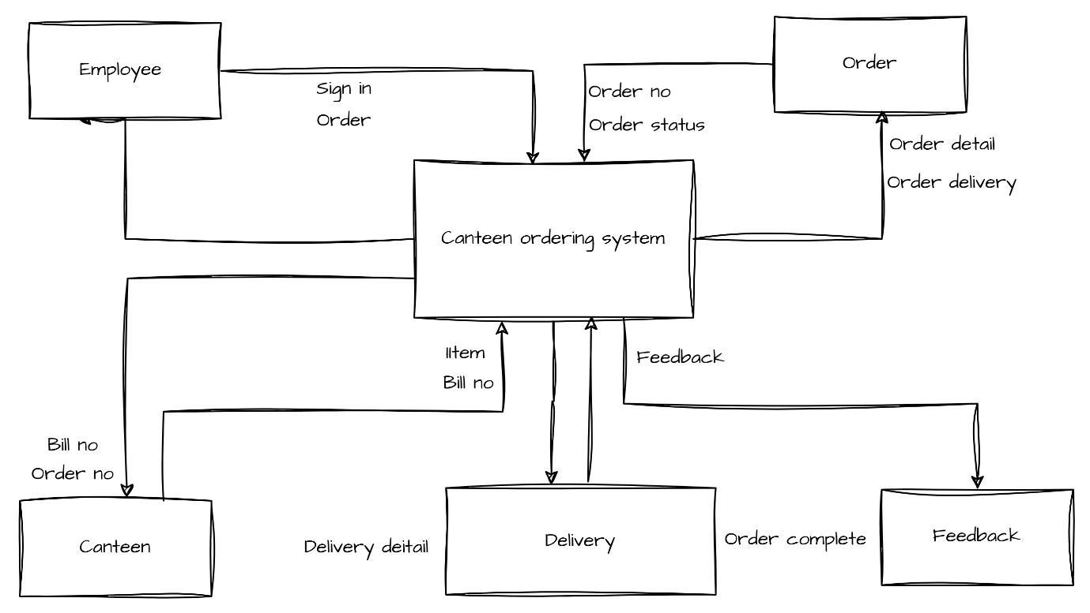

***6. MAIN FEATURES THAT NEED TO BE DEVELOPED***

* ***User Interface****: Registration, login, menu browsing, and order placement*
* ***Admin Interface****: Menu management, order tracking, and reporting.*
* ***Payment Integration****: Support for multiple payment methods.*
* ***Order Tracking****: Real-time status updates and notifications.*
* ***Feedback System****: Collect and manage user feedback.*

***7. IN-SCOPE AND OUT-OF-SCOPE ITEMS***

***In-Scope****:*

* *Online order placement and payment.*
* *Menu management and customization.*
* *Order tracking and notifications.*
* *Feedback and rating system.*
* *Reporting and analytics.*

***Out-of-Scope****:*

* *Delivery service (focus on in-canteen pickup).*
* *Inventory management beyond order-related updates.*
* *Integration with external restaurant*

***8.ER DIAGRAM OF THE SYSTEM***

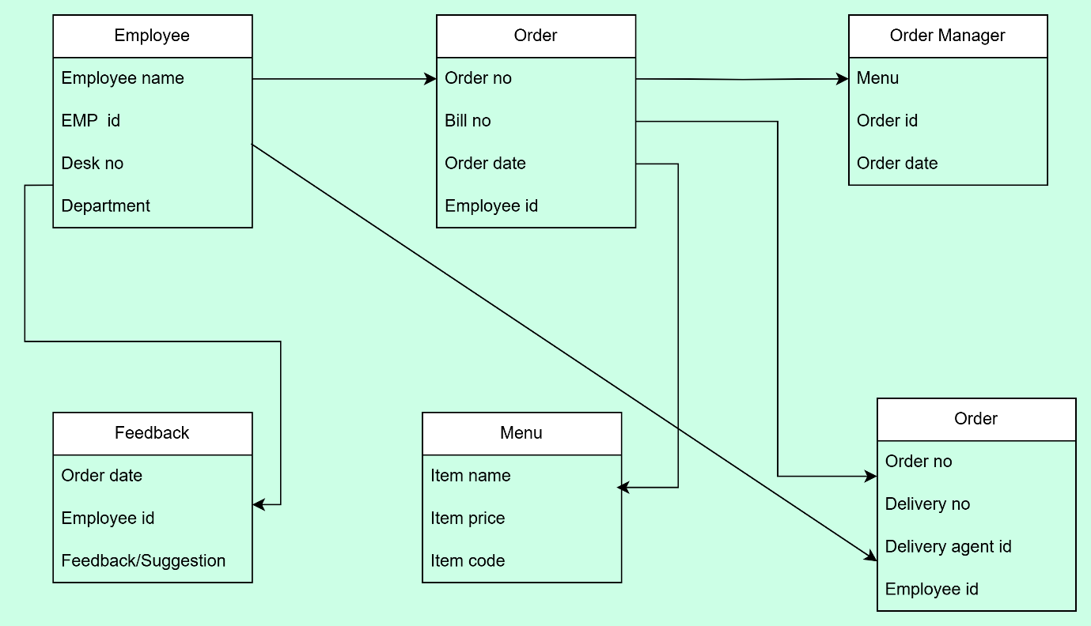

***9. BUSINESS REQUIREMENTS***

***Functional Requirements****:*

* *The system must allow users to register, log in, and manage their accounts.*
* *The system must provide a real-time menu with availability updates.*
* *The system must process orders and payments securely.*
* *The system must offer real-time order status updates.*

***Non-Functional Requirements****:*

* *The system should have a user-friendly interface.*
* *The system must be scalable to handle peak times.*
* *The system should ensure data security and privacy.*

***10.WIREFRAMES OF THE MODEL***

